Article Title
Author Name^{1*}, Author Name ², and Author Name ³
¹Department of XXX, Institute of YYY, Kolkata-00000
² Department of AAA, Institute of ZZZ, Kolkata-00000
³Department of BBB, Institute of YYY, Kolkata-00000

Email: abcdef@gmail.com

Abstract

The abstract should contain maximum of 300 words. No abbreviation should be mentioned in the abstract. Give a brief summary of your research work.

Keywords: Maximum, five keywords

Introduction

Welding may be defined as joining of two similar or dissimilar materials with the help of fusion or pressure or by both of them. Due to availability of electric current and continuous challenging situation in industries, modern engineering demands the development of welding with an accelerating rate. [1].Because of high gas velocity and heat input, PAW can operate in the keyhole mode. Compared with electron beam and laser welding, keyhole PAW has different advantages such as cost effectiveness, lower shrinkage and distortion,hence it is widely used in manufacturing structures with medium thickness.However, the keyhole establishment and sustainment during the initial stage of PAW process,i.e., the keyholing process, has a critical effect on the process stability and the weld quality. Thus, modelling and simulating of the keyholing process and its influence on fluid flow and heat transfer in keyhole PAW process is of great significance to completely understand the process mechanism [2].

Table 1. Example of a Table. Table should be inserted inside the text.
Column 1 | Column 2 | Column 3 | Column 4 | Column 5 | Column 6 | Column 7

Section Heading
  - Section Subheading
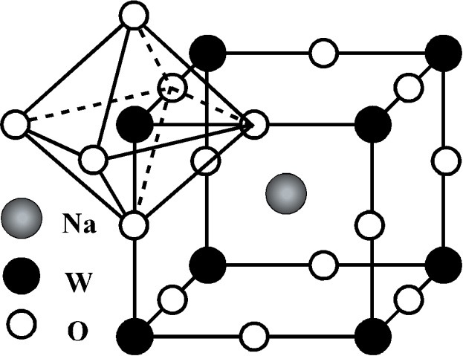
In this process, the high-temperature and high-velocity plasma arc strikes on work piece, melts metal, creates a molten pool and finally penetrates through the pool. Due to generation of huge amount of heat at a very narrow zone a complete keyhole may form. After the formation of complete key hole some efflux plasma may exit at the back side of the work piece. So, by detecting efflux plasma keyhole signal may be obtained. Fig. 2 shows development of quasi keyhole process in time sequence. When the current changes from base to peak current, depth of weld pool and partial keyhole increases.

FIG 1.Schematic Diagram of the figure.

Conclusion

Write the conclusion here. The abstract should not be replicated as the abstract. It should focus on the importance of the work carried out.

- Acknowledgements

REFERENCES

[1] A Surname, B Surname and C Surname, Journal Name 37, 074203 (2015)

[2] A Surname, B Surname and C Surname, Journal Name 37, 231 (2018)

[3] A Surname, B Surname and C Surname, Journal Name 63, 45 (2016)

